Physics 20 Lesson 27 Conservation of Energy

In this lesson we will learn about one of the most powerful tools for solving physics problems utilizing the Law of Conservation of Energy.

# Law of Conservation of Energy

The Law of Conservation of Energy states that **the total amount of energy in a system remains constant**. The energy may be transformed from one type to another, from kinetic to potential or kinetic to heat, but the total amount of energy is conserved. For example, imagine a skier starting from rest at the top of the hill at Canada Olympic Park. She has a lot of gravitational potential energy due to the vertical distance from the top of the hill to the bottom. As she slides down the hill, her gravitational potential energy becomes less and less while her kinetic energy (i.e. – her speed) becomes larger and larger. If the hill was frictionless, all of her gravitational potential energy from the top of the hill would be transformed into her kinetic energy at the bottom. In equation form:

 (frictionless)

Of course, there is a substantial amount of friction between the skis and the snow. Therefore, some of the initial gravitational potential energy will be converted into heat energy and some will be converted into kinetic energy. The skier’s kinetic energy at the bottom of the hill will be the initial gravitational energy minus the heat lost to friction.



In these types of problems we are applying the Law of Energy Conservation. This is a very powerful principle or law and we can use it to solve problems which would be quite difficult if we were only using kinematics or dynamics.

# Conservation of energy – problem solving

The basic ***method*** for solving problems using the conservation of energy is as follows:

1. Determine the different forms of energy that are present at the beginning of the problem.

* If the object is initially higher than it will be at the end of the problem it has gravitational potential energy.
* If it is in motion it has kinetic energy.
* If a spring or an elastic is being stretched or compressed, elastic potential energy is involved.
* If a force is being applied over a distance then work is being done.

2. Determine the different forms of energy that are present at the end of the problem.

* If the object is higher than it was at the beginning it has gravitational potential energy.
* If it is in motion it has kinetic energy.
* If a spring or an elastic is being stretched or compressed, elastic potential energy is involved.
* If a force is being applied over a distance then work is being done.

3. Apply the principle of conservation of energy **Initial energies = Final energies** to the problem.

Write a mathematical expression that equates all of the initial forms of energy (gravitational potential, elastic potential, kinetic, work) with all of the final forms of energy (gravitational potential, elastic potential, kinetic, work, heat, etc.)

4. Substitute in the appropriate equations for each form of energy and solve for the requested value.

The main thing to get used to when solving problems in this way is that you are creating a new mathematical equation for each situation that you encounter. The equation will depend on the context of what is happening in the problem at hand. Be warned, students who try to memorize every type of possible context (there are thousands of possible contexts) end up frustrated and helpless. But students who learn to apply the process/method of energy conservation find the problems easy to solve and work with.

A 50 kg object falls 490.5 m. What is the speed of the object just before impact with the ground?

**Solution**:

The object starts from a point higher than the ground. If we say that the ground is the zero potential point, the object initially has potential energy (Ep i). In the end it has kinetic energy (Ek f).



Using conservation of energy we relate the initial energies with the final energies.

Rearrange the equation and solve.

Substitute the appropriate equations from the formula sheet into the relationship. Note that mass cancels out.

A snowmobile driver with a mass of 100 kg traveling at 15.0 m/s slams into a snow drift. If the driver sinks 0.50 m into the snow drift before stopping, what is the retarding force applied by the snow drift?

**Solution**:

The driver initially has kinetic energy due to his motion (Ek i). The snow drift applies a force (F) on the driver through a distance (∆d), which means that work (W = F∆d) is being done on the driver. In the end he is not moving (no kinetic energy).



Substitute the appropriate equations from the formula sheet into the relationship.

Using conservation of energy we relate the initial kinetic energy with the work done to stop the driver.

Rearrange the equation and solve.



A 5.0 kg object is thrown vertically down from the top of a 50.0 m tower with a speed of 15.0 m/s. What is the speed of the object at the bottom of the tower just before it hits the ground?

**Solution**:

The object starts from a point higher than the ground (Ep i) and it has an initial speed (Ek i). In the end it has kinetic energy (Ek f).



Using conservation of energy we relate the initial energies with the final energies.

Rearrange the equation and solve.

Substitute the appropriate equations from the formula sheet into the relationship. Note that mass cancels out.

A 5.0 gram bullet enters a wooden block at 350 m/s and exits the 20 cm wide block at 150 m/s. What was the force applied to the bullet by the block?

**Solution**:

There are at least two ways to conceptualise this problem. First, the bullet has an initial kinetic energy (Ek i) and a final kinetic energy (Ek f). Work was done on the bullet (i.e. force through a distance) to slow it down.



The second way is to use the concept of work (W = ∆Ek) that we learned about in Lesson 26. Since the wood is slowing the bullet down the work done is negative.



In any case, we substitute in our equations and solve for the unknown.



A 25 kg object resting at the top of a 15 m high inclined plane begins to slide down the plane. At the bottom of the plane the object has a speed of 14.0 m/s.

A. How much heat energy was produced?

The objects initial gravitational potential energy (Ep i) is converted into kinetic (Ek f) and heat energy (Eh) due to friction.



B. If the incline is 35.0 m long, what is the frictional force?



A toy car with mass 348 g is pushed up against a compression spring. The spring is compressed by 5.3 cm. When the car is released its final speed is 7.3 m/s. What is the spring constant for the compression spring?



**Solution**:

When the car is pushed up against the spring the car has spring potential energy (Ep i). When it is released it has kinetic energy (Ek f).

# Practice Problems

1. A motorcycle rider is trying to leap across the canyon as shown in the figure by driving horizontally off the cliff. When it leaves the cliff, the cycle has a speed of 38.0 m/s. Ignoring air resistance, find the speed with which the cycle strikes the ground on the other side. (46.2 m/s)

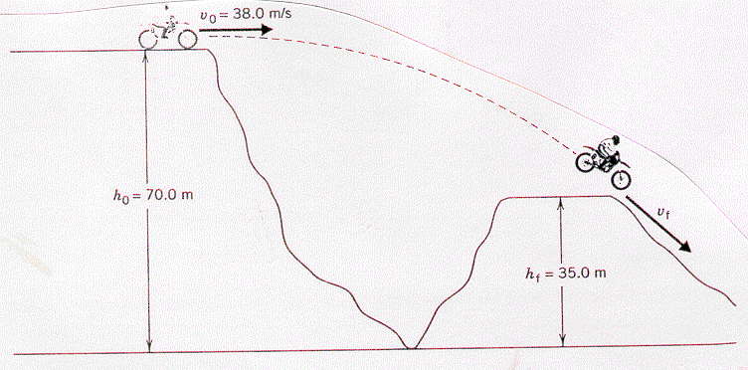

2. A 6.00 m rope is tied to a tree limb and used as a swing. A person starts from rest with the rope held in a horizontal orientation, as in the figure. Ignoring friction and air resistance, determine how fast the person is moving at the lowest point on the circular arc of the swing. (10.8 m/s)

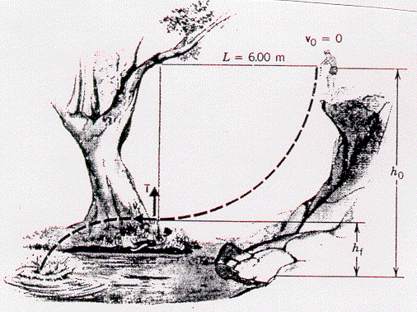

3. One of the fastest roller coasters (2000 kg) in the world is the Magnum XL - 200 at Cedar Point Park in Sandusky, Ohio. This ride includes an initial vertical drop of 59.3 m. Assume that the roller coaster has a speed of nearly zero as it crests the top of the hill.

A. If the track was frictionless, find the speed of the roller coaster at the bottom of the hill. (34.1 m/s)

B. The actual speed of the roller coaster at the bottom is 32.2 m/s. If the length of track is 125 m, what is the average frictional force acting on the roller coaster? (1.01 x 103 N)

# Hand-in Assignment

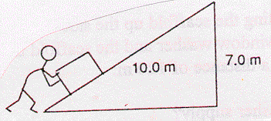

1. An 80.0 kg box is pushed up a frictionless incline as shown in the diagram. How much work is done on the box in moving it to the top? (Hint, think energy, not forces.) (5.49 kJ)

2. A 75 g arrow is fired horizontally. The bow string exerts an average force of 65 N on the arrow over a distance of 0.90 m. With what speed does the arrow leave the bow string? (39 m/s)

3. In the high jump, the kinetic energy of an athlete is transformed into gravitational potential energy. With what minimum speed must the athlete leave the ground in order to lift his center of mass 2.10 m and cross the bar with a speed of 0.80 m/s? (6.5 m/s)

4. A 50.0 kg pole vaulter running at 10.0 m/s vaults over the bar. Assuming that the vaulter's horizontal component of velocity over the bar is 1.00 m/s and disregarding air resistance, how high was the jump? (5.05 m)

5. If a 4.00 kg board skidding across the floor with an initial speed of 5.50 m/s comes to rest, how much thermal energy is produced? (60.5 J)

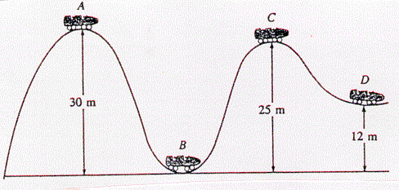6. A roller coaster is shown in the drawing. Assuming no friction, calculate the speed at points B, C, D, assuming it has a speed of 1.80 m/s at point A. (24.3 m/s, 10.1 m/s, 18.9 m/s)

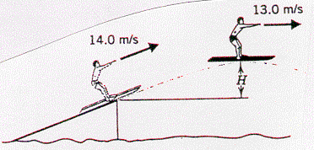

7. A water skier lets go of the tow rope upon leaving the end of a jump ramp at a speed of 14.0 m/s. As the drawing indicates, the skier has a speed of 13.0 m/s at the highest point of the jump. Ignoring air resistance, determine the skier’s height H above the top of the ramp at the highest point. (1.38 m)

8. A roller coaster vehicle with occupants has a mass of 2.9 x 103 kg. It starts at point A with a speed of 14 m/s and slides down the track through a vertical distance of 25 m to B. It then climbs in the direction of point C which is 36 m above B. An interesting feature of this roller coaster is that due to cost-over-runs and poor planning, the track ends at point C. The occupant is the chief design engineer of the roller coaster ride. Estimate the speed of the vehicle at point B and then determine whether the fellow survives the ride. (26 m/s)

9. The speed of a hockey puck (mass = 100.0 g) decreases from 45.00 m/s to 42.68 m/s in coasting 16.00 m across the ice.

a. How much thermal energy was produced? (10.17 J)

b. What frictional force was acting on the puck? (0.6357 N)

10. During an automobile accident investigation, a police officer measured the skid marks left by a car (mass = 1500 kg) to be 65 m long. If the frictional force on the car was 7.66 kN during the skid, was the car going faster than the 100 km/h speed limit before applying the brakes? (slower)

11. A 45.0 kg box initially at rest slides from the top of a 12.5 m long incline. The incline is 5.0 m high at the top. If the box reaches the bottom of the incline at a speed of 5.0 m/s, what is the force of friction on the box along the incline?

(1.3 x 102 N)

4.0 kg

12 kg

5.0 m

*12. For the pulley system illustrated to the right, when the masses are released, what is the final speed of the 12 kg mass just before it hits the floor? (7.0 m/s)

Hot Wheels Activity

**Problem:**

What is the relationship between the potential energy of a car at the top of a hill and its kinetic energy at the bottom of a hill? How much heat was lost due to friction? What is the average frictional force of the track on the car? (Hint: You cannot use conservation of energy to calculate the speed at the bottom of the ramp. Why?)

ramp

h (measure)

Δdx (measure)

Δdy (measure)

Ep = m g h

Ek = ½ m v2

table top

